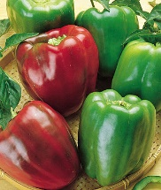 | California Wonder Peppers - HEIRLOOM. The standard bell pepper for many decades, this 1928 introduction is still the largest open-pollinated, heirloom bell you can grow. A perfect stuffing pepper-blocky 4" x 3 1/2", thick-walled, tender and flavorful.
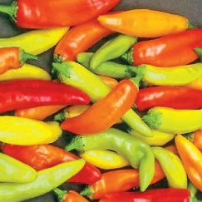 | Hungarian Wax Peppers - A Mexican favorite that's four to five times hotter than jalapeno: distinctive, pungent flavor. Heat-lovers, here's another Mexican favorite used in a variety of dishes, from salsas to soups, with a distinctive, pungent flavor. Large 2-3' plants produce fruits about 5" long that start out bright yellow and turn red as they mature. They make great pickled peppers.
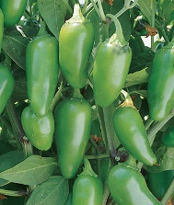 | Jalapeno Pepper - Dark green, medium-hot, thick-walled peppers 3" long, 1" wide, with rounded tips. Matures to dark red. Space plants 18-24" apart. CAUTION: Use rubber gloves or clean hot peppers under running water to avoid skin burn from the pepper juice.
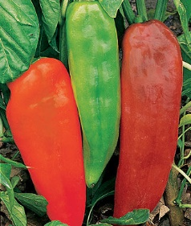 | Corno di Toro Sweet Peppers – These peppers have a sweet, crisp, full-bodied flavor. A tasty favorite eaten raw, fried, stuffed or grilled.
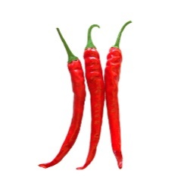 | Ring-O-Fire is an improved cayenne that matures earlier and has a glossy sheen with a fire engine red color. Prolific and dependable plants reach heights of 18" tall and produce loads of thin-skinned fruits, great for eating fresh, dried or powdered.



