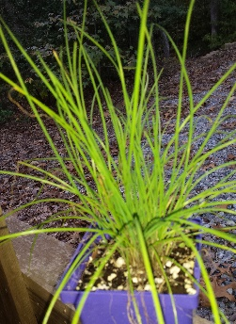 | Chives – Perennial / Sun / 6 – 8 inches tall - Chives are an herb member of the onion family. They can be grown in a large pot (6 inches or more) near your back door for convenience. In June to July they have a lovely purple bloom which can be cut to promote growth and preserve flavor. The hollow “leaves” are usually not cooked but sprinkled on at the end for additional flavor. Can be grown from seeds or divided in spring or fall.
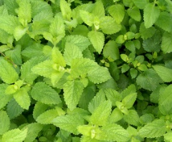 | Lemon Balm – Perennial – Full Sun – 30 inches tall – will die back in winter. Useful for teas and some medicinal uses. Can be propagated by root divisions or stated from seeds.
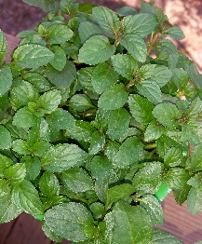 | Mint – Perennial – Mints come in many different flavors. They are used to add flavor when cooking and can be added to some drinks. It will die back in the winter and reemerge the next spring. Mint spreads easily and should be confined. It can be propagated by stem cuttings.
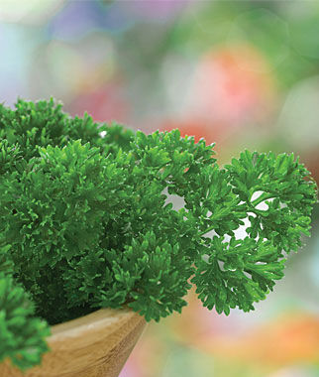 | Parsley – Wonderful flavor and good source of vitamin C. Biennial. Will go to seed on the second year.
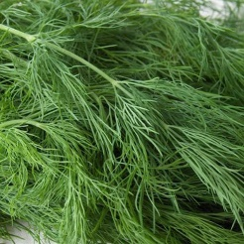 | Dill – may reseed – Full Sun – 2 to 3 feet – Favorite in the kitchen for both leaves and seeds.



